Evidence

Micro Service

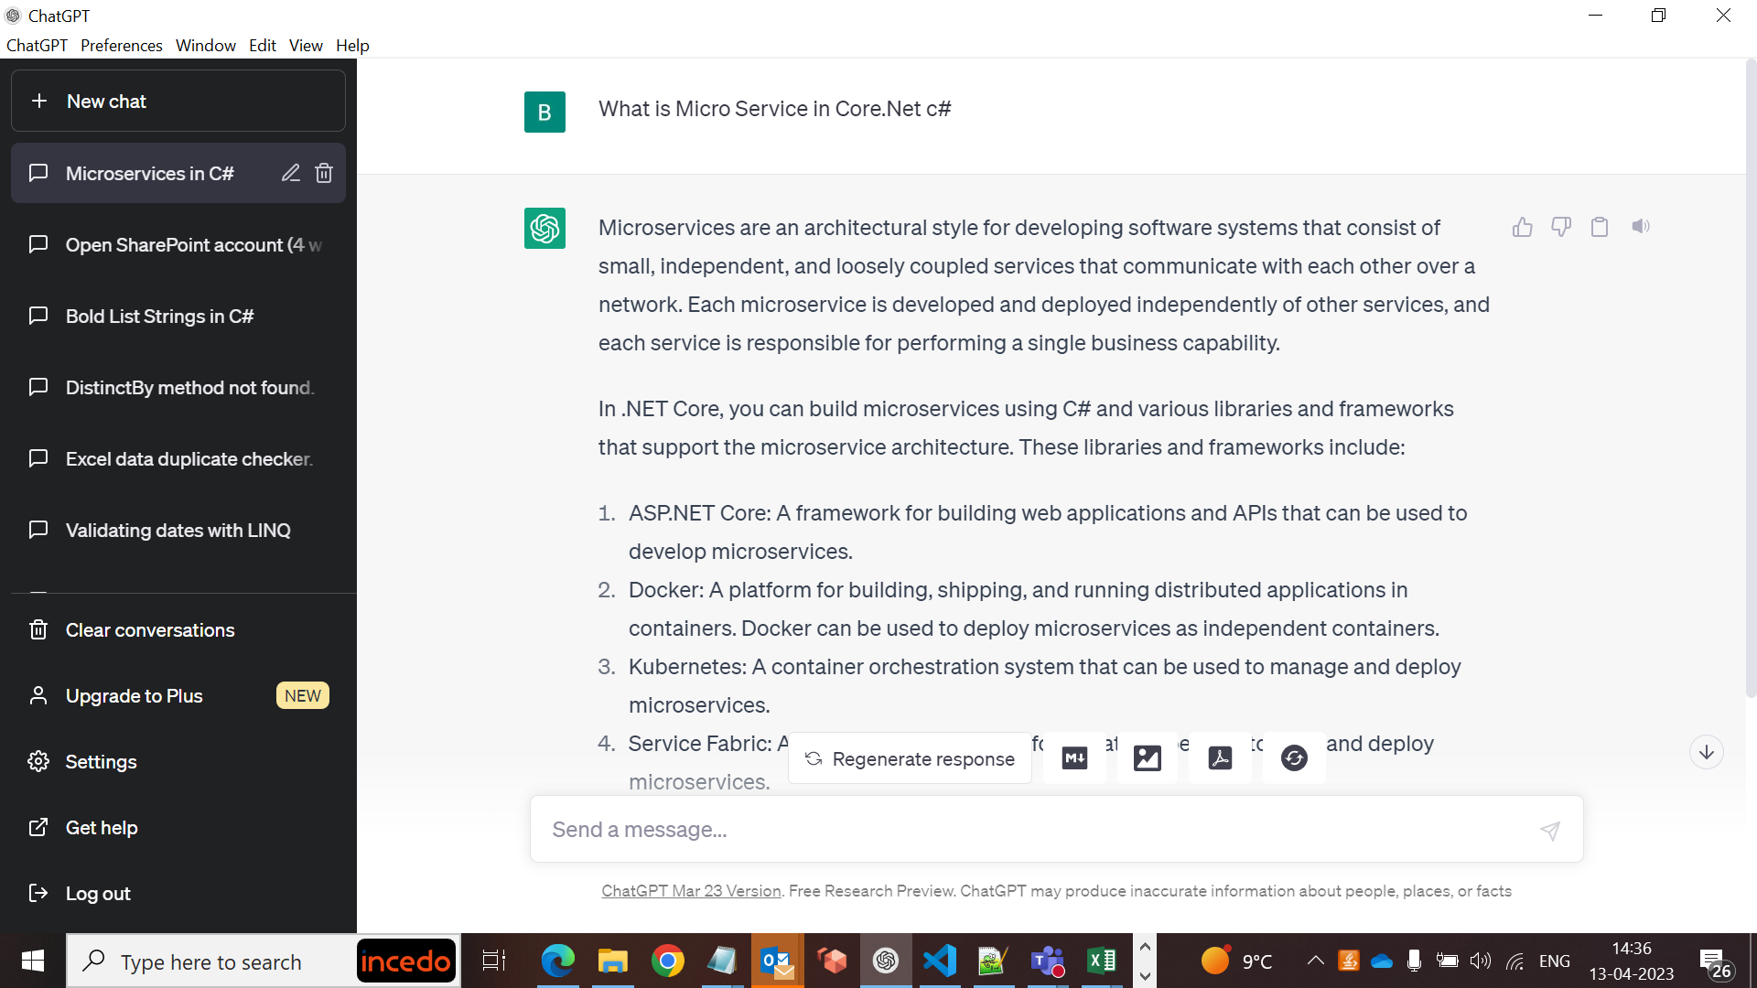

API

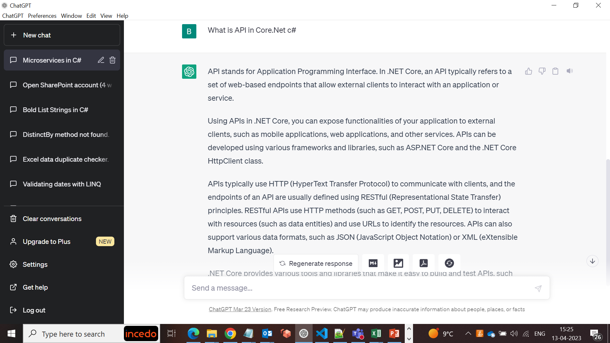

Micros Service vs API

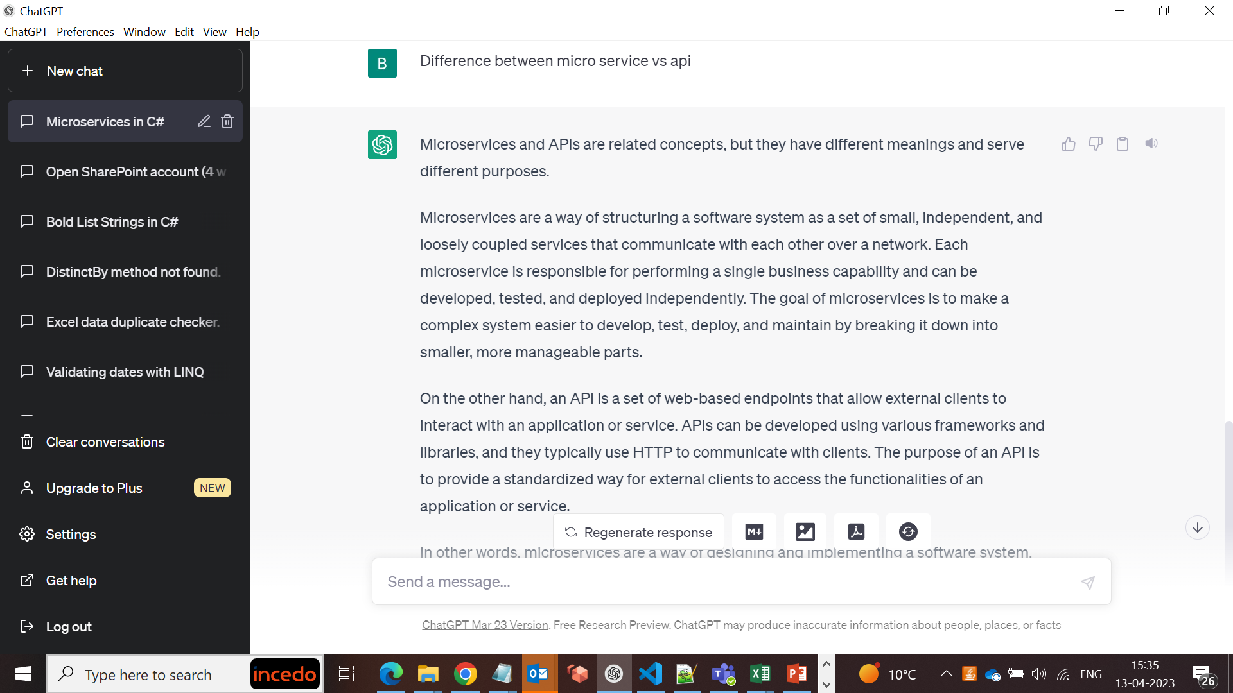

Micro Service program example

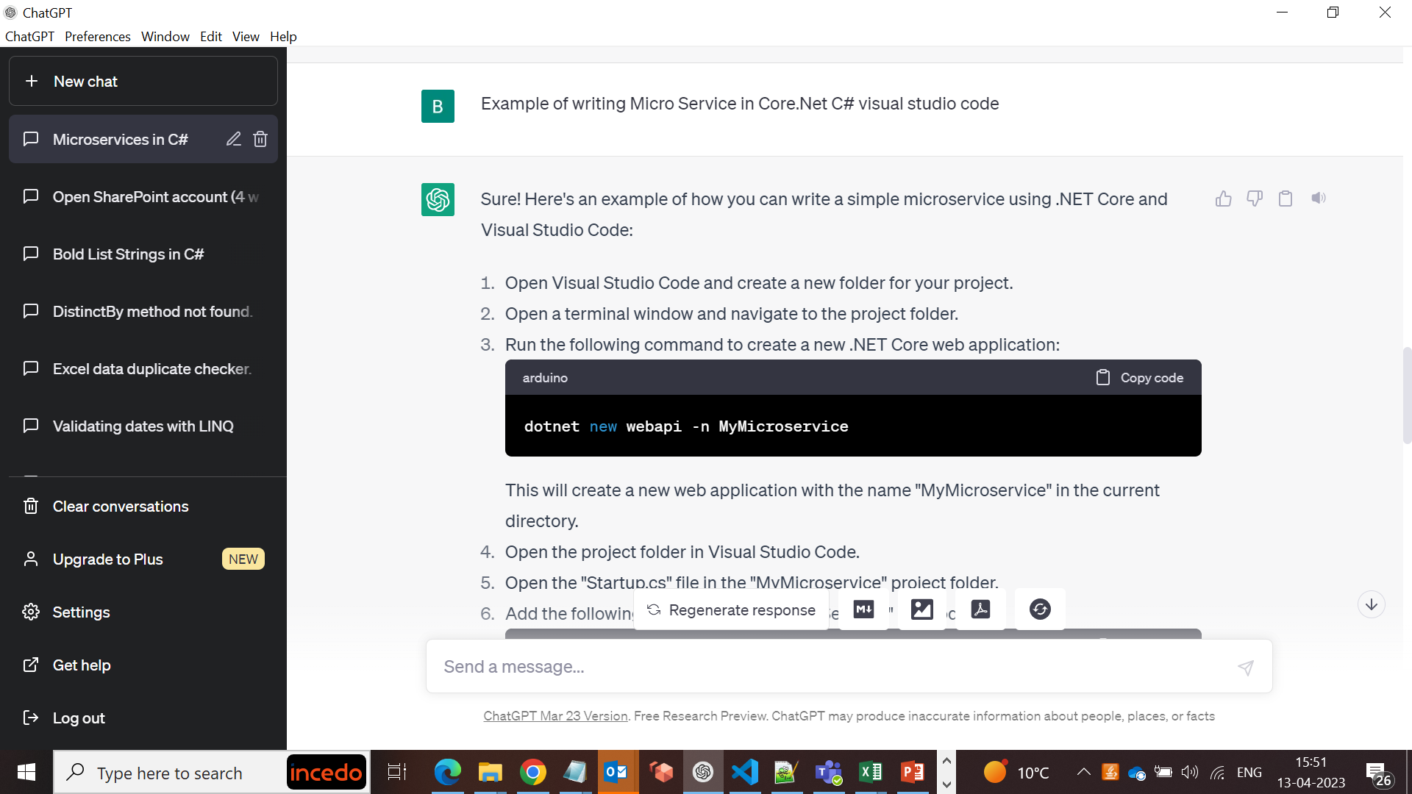

API program example

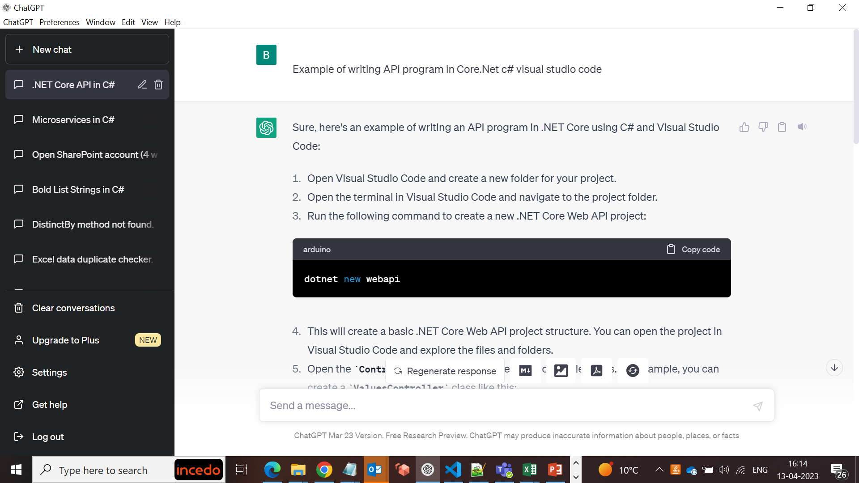

Micro Service program example again

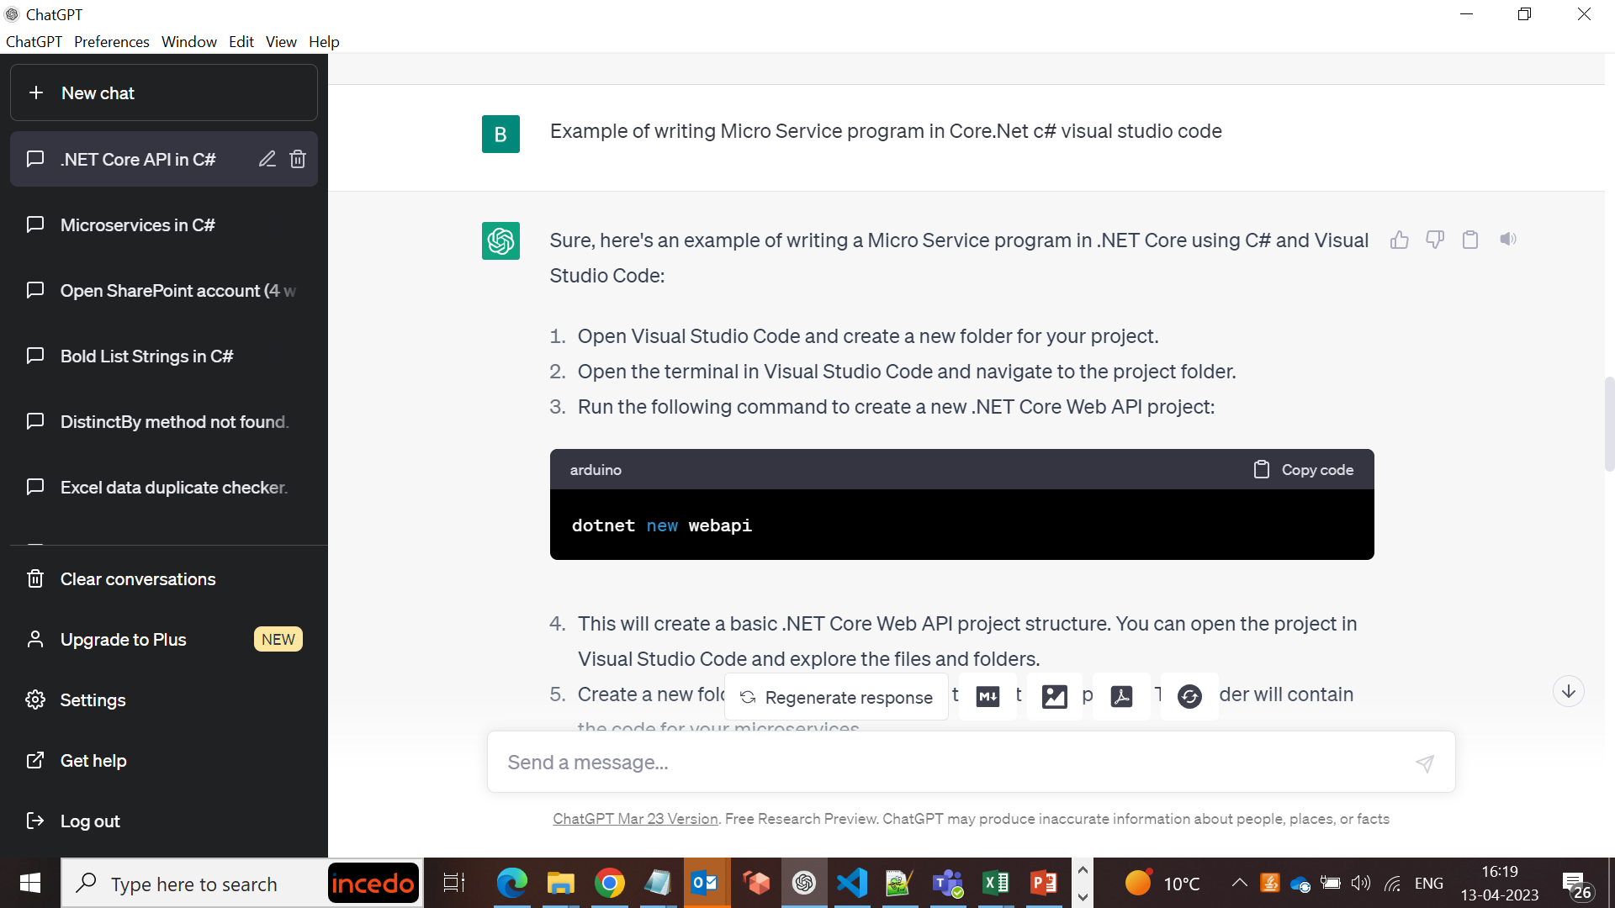

How to convert console program using API controller to micro service and api core.net using visual studio code

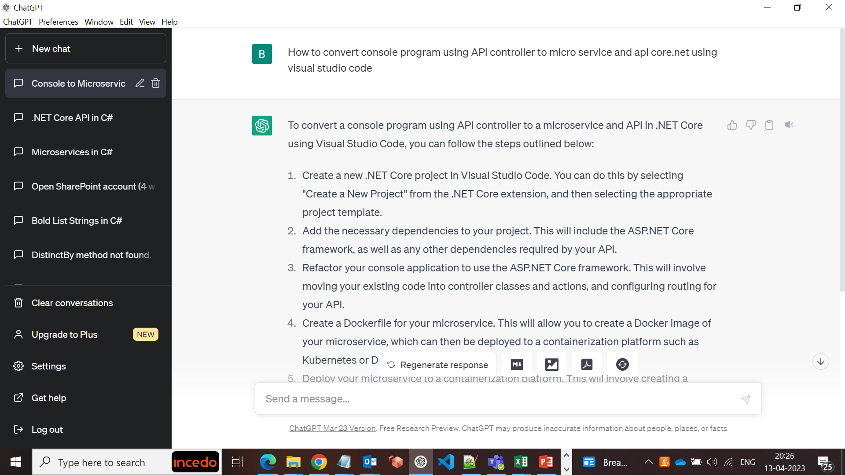

How to convert console program using API controller to micro service and api core.net using visual studio code

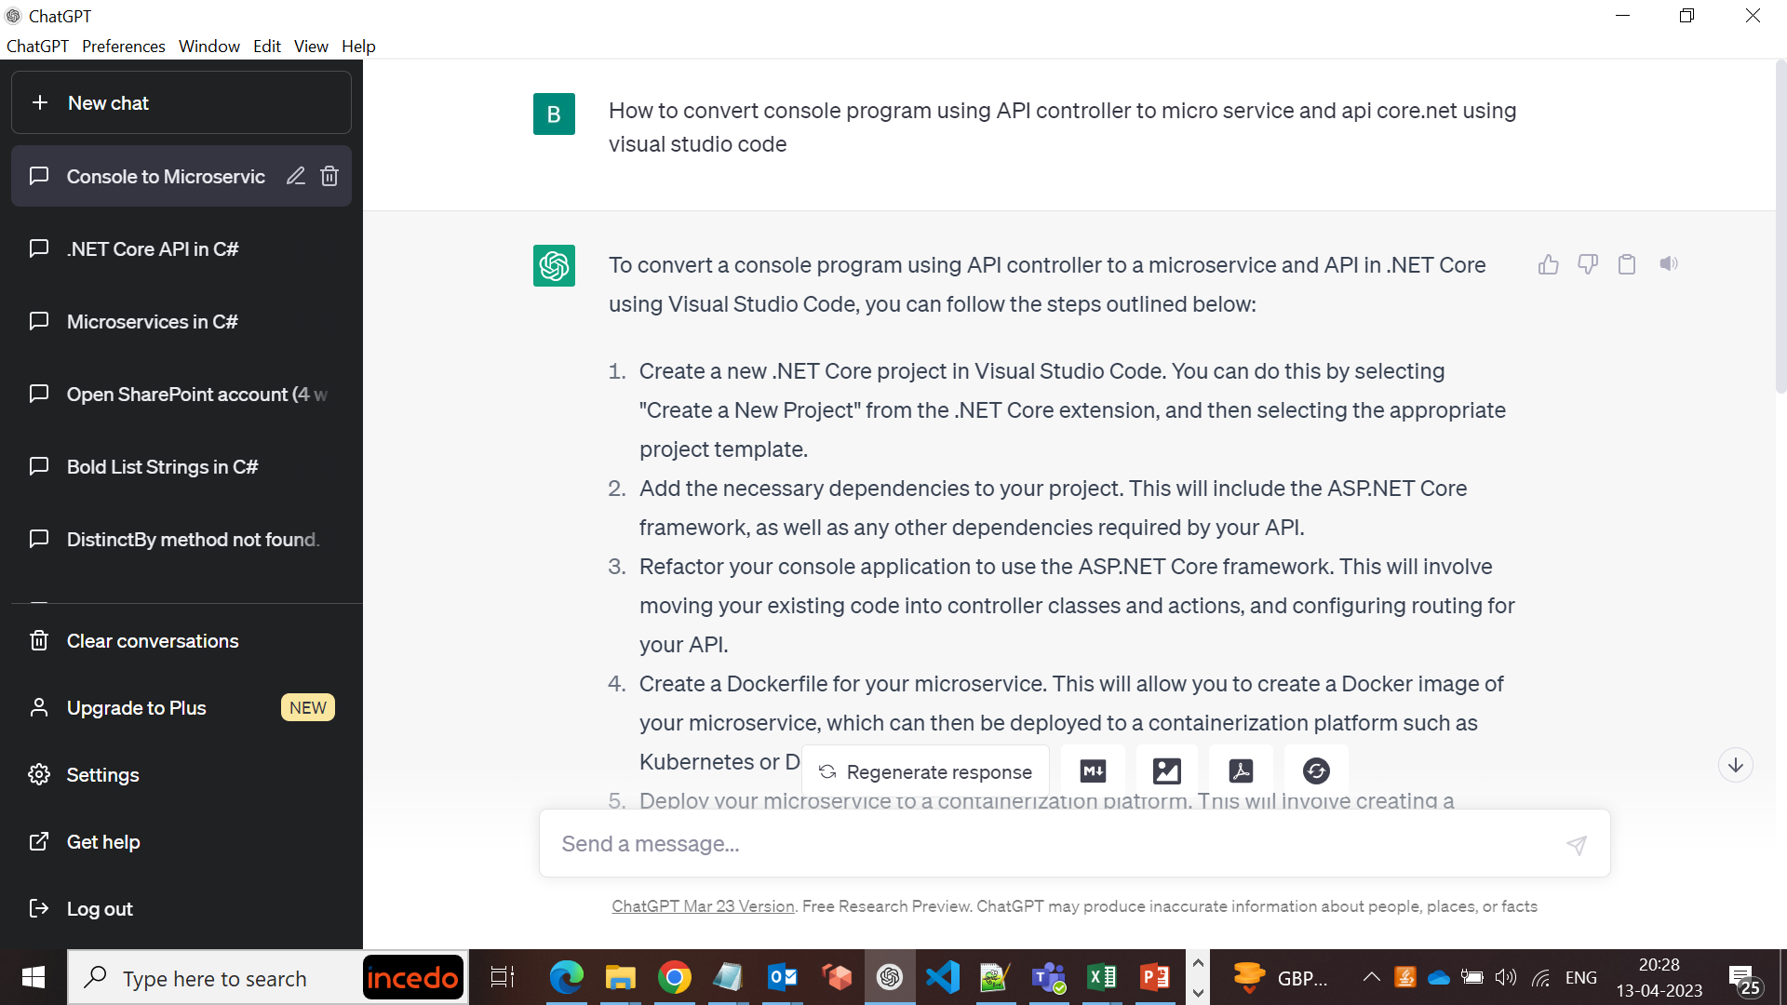

Write a micro service program core.net c# using visual studio code

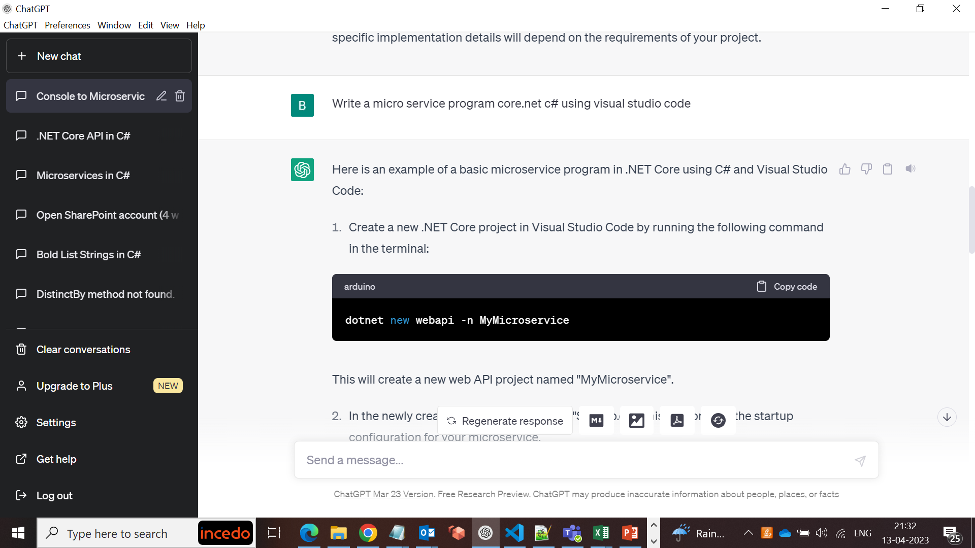

How to convert List<string> to ActionResult<string> core.net micro service c# visual studio code

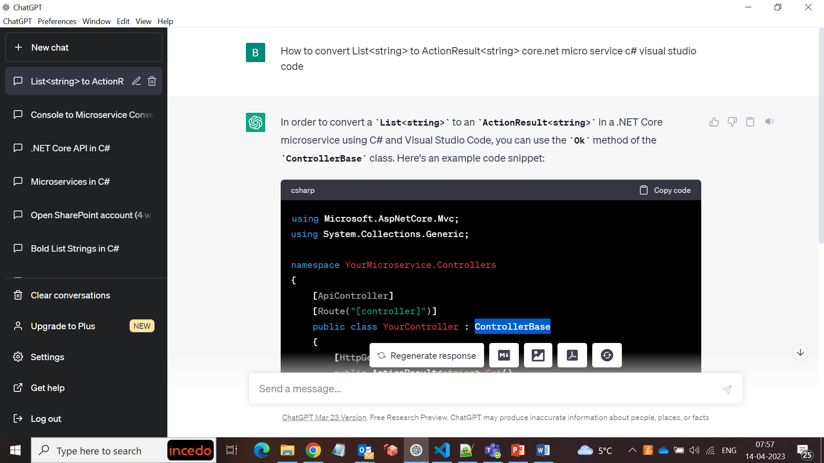

How use Micro Service from API core.net API c# visual studio code

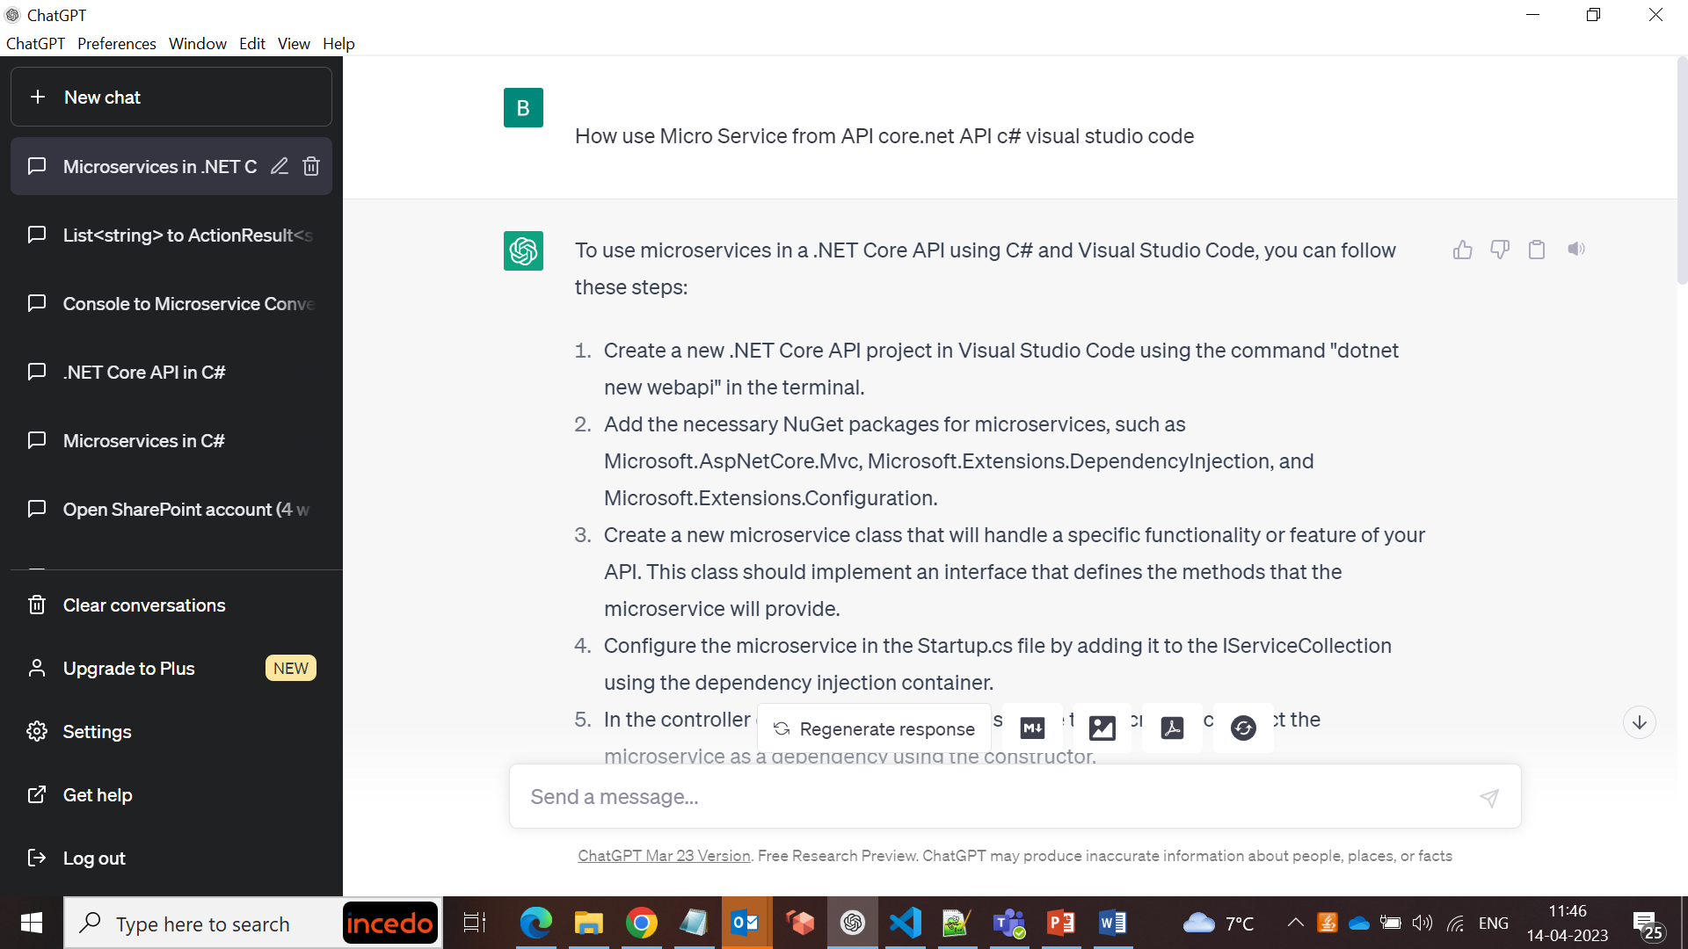

How use Micro Service from Docker core.net API c# visual studio code

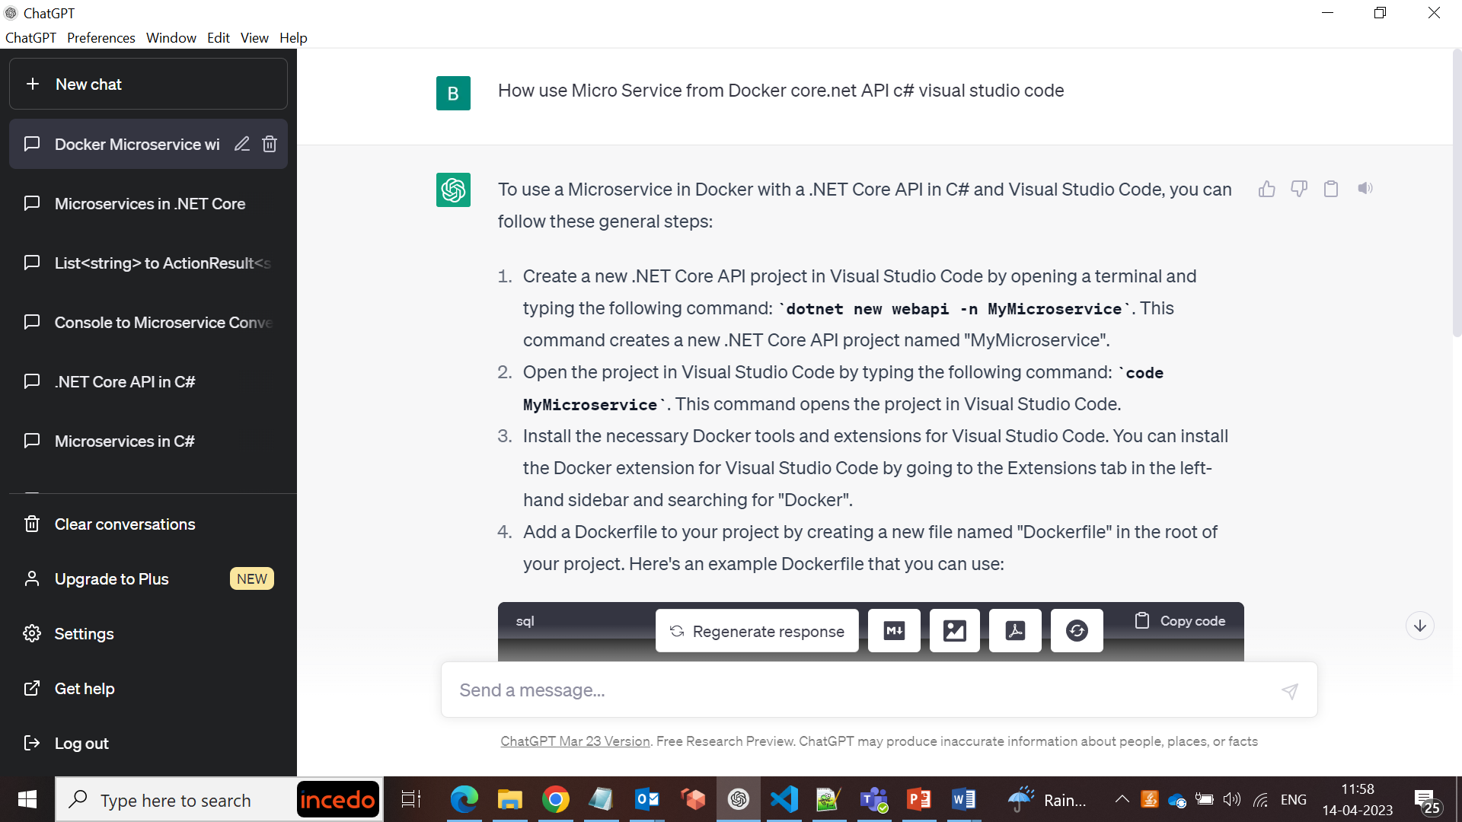

How to install SharePoint in Visual Studio Code Micro Service core.net c#

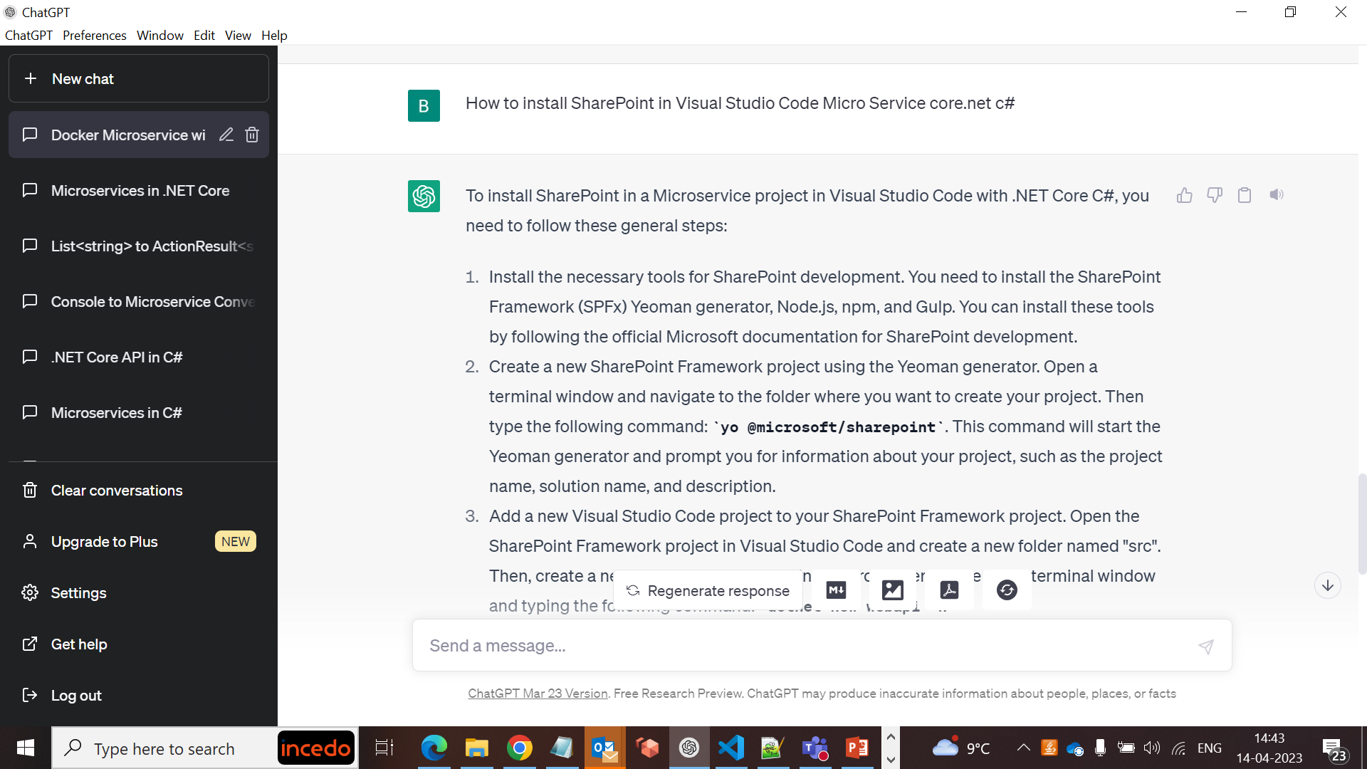

How to install SharePoint package micro service core.net c# visual studio code

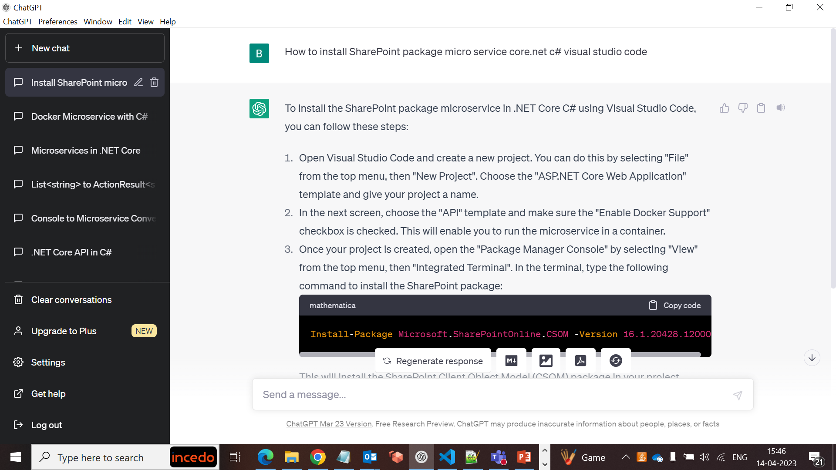

How to access a URL from a micro service core.net c# visual studio code

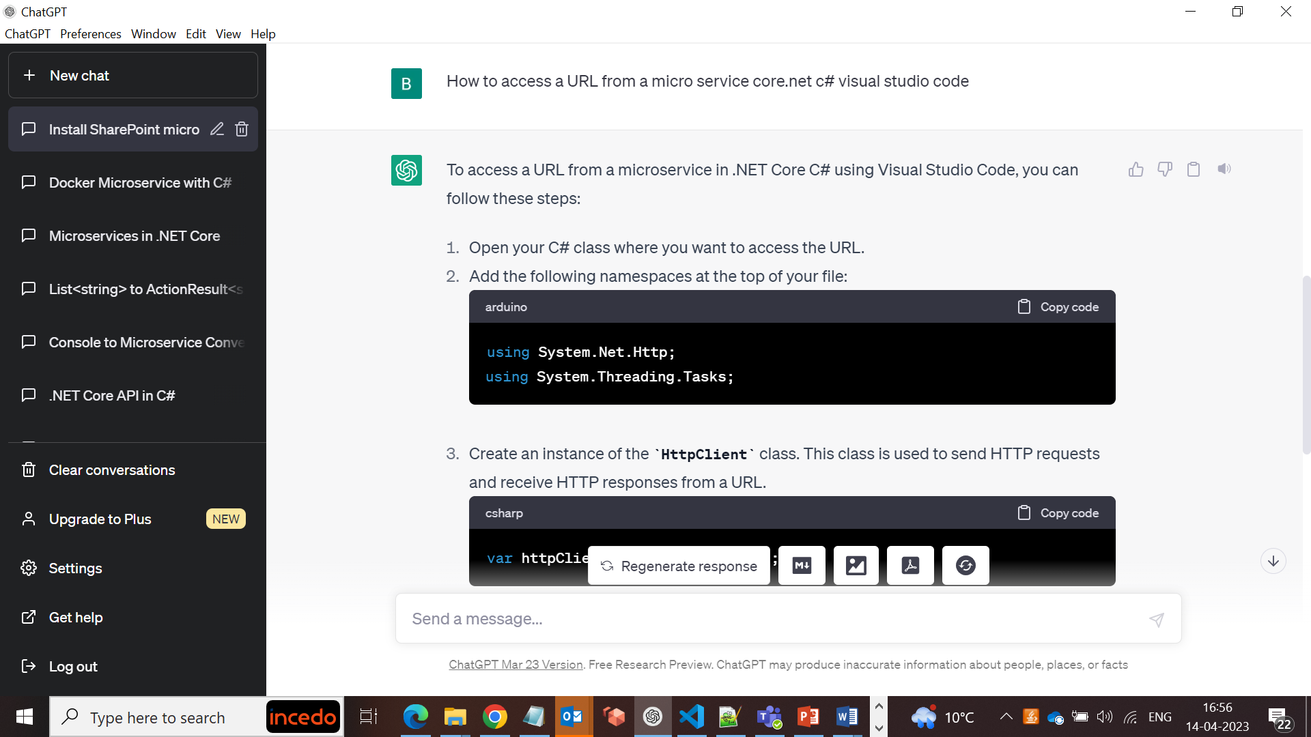

Write a program to access a URL from a micro service core.net c# visual studio code

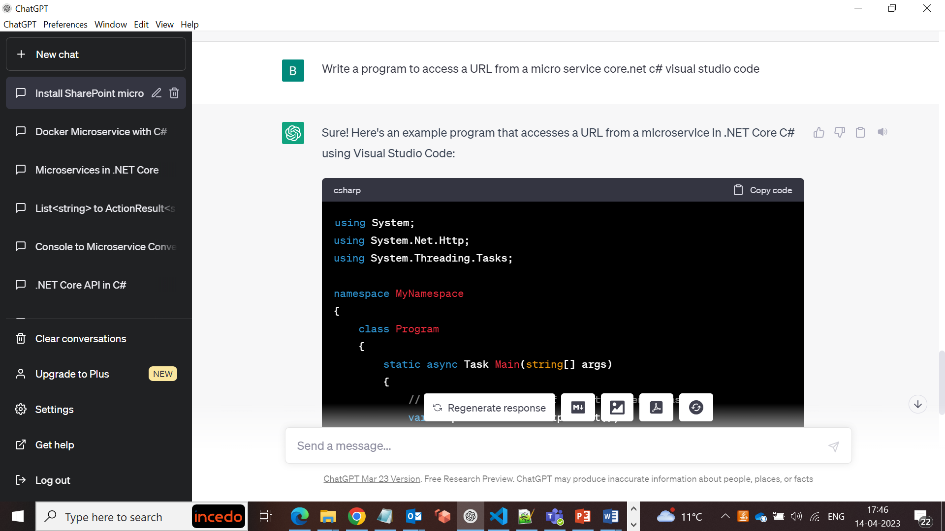

What is Task in core.net micro service core.net c#

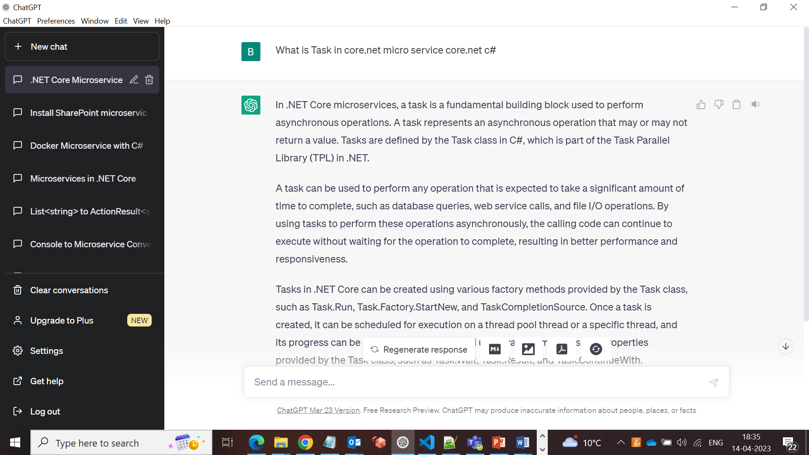

How to receive excel as input file from react.js using core.net micro service visual studio code

